**Annual Report of the Intellectual Property Court of the Supreme People’s Court**

**(2024)**



The Intellectual Property Court of the Supreme People’s Court

**Contents**

**Preface 1**

**I. Enhancing judicial protection of sci-tech innovation to support development of new-quality productive forces 3**

(I) Focusing on protection of innovative achievements 3

(II) Strengthening protection for innovative entities. 8

(III) Providing substantive protection for innovative conducts 11

**II. Strengthening judicial protection of fair competition to promote development of a unified national market 16**

(I) Enhancing guidance of adjudicative rules 16

(II) Intensifying anti-monopoly in the field of people’s livelihood 17

(III) Strengthening protection of technical secrets 18

(IV) Advancing litigation integrity 19

**III. Upholding equal protection by the law to serve high-level opening-up 21**

(I) Providing equal protection for both Chinese and foreign parties by the law 21

(II)Engaging in global intellectual property governance actively 23

(III) Deepening international exchanges and cooperation continuously 24

**IV. Practicing the New-era “Fengqiao Experience” to substantially resolve disputes and conflicts 26**

(I) Clarifying and then resolving disputes effectively 26

(II) Upholding the judicial philosophy of “reversing judgements wherever possible rather than remanding for retrail” 28

(III) Increasing circuit adjudication 29

**V. Deepening institutional and mechanism reforms to comprehensively enhance adjudication quality and efficiency 29**

(I) Deepening the Court’s reform continuously 30

(II) Strengthening internal supervision of adjudications 30

(III) Intensifying supervision and guidance of lower courts 31

(IV) Carrying out cooperation to enhance protection synergy 32

(V) Enhancing cultivation of a digital court 34

**Concluding Remarks 34**

**Appendix 37**

**Preface**

The year of 2024 was a pivotal year for achieving the goals and tasks of the 14th National Five-Year Plan, and also marked the sixth year of the pilot reform conducted by the Intellectual Property Court of the Supreme People’s Court (hereinafter referred to as the Court). Under the guidance of Xi Jinping Thought on Socialism with Chinese Characteristics for a New Era, the Court thoroughly implemented Xi Jinping Thought on the Rule of Law, and fully carried out the essentials of the 20th CPC National Congress and those of the Second and Third Plenary Sessions of the 20th CPC Central Committee. The Court worked earnestly to serve the country’s overall development and people’s judicial needs, fully played the role of the national-level adjudication mechanism for IP appeals, continuously improved the quality and efficiency of adjudication of technology-related intellectual property and anti-monopoly cases, and vigorously promoted the development of new-quality productive forces led by sci-tech innovation. The annual report on the Court’s work in 2024 is hereby released to enhance the public understanding and oversight of the Court’s work by all sectors of society.

In 2024, the Court fulfilled its functions of stimulating sci-tech innovation, maintaining fair competition and supporting opening up through adjudication of cases. Notable progress was made. First of all, the overall trend of adjudication work has continued to improve. A total of 6,229 technology-related intellectual property cases and anti-monopoly cases were accepted (including 3,015 new cases). 4,213 cases were concluded, while 2,016 were pending, reflecting a year-on-year decrease of 37.3%. Secondly, the adjudication quality and efficiency continued to improve. The average adjudication duration for substantive cases was shortened by 11.5 days. A number of cases with significant impact were concluded, including the case presided over by a Justice of the Supreme People’s Court (hereinafter referred to as the SPC) on the National Constitution Day, the “*New Energy Vehicle Chassis*” case, and the first Anti-Anti-Suit Injunction case involving intellectual property. One written judgment and two court hearings were respectively selected, from nationwide courts, into “100 Excellent Written Judgments” and “100 Excellent Court Hearings”. Four judgments were honored as the SPC Excellent Written Judgments for the year from 2022 to 2023. Thirdly, more efforts were put into effective settlement of disputes. Under the principle of “reversing judgments wherever possible rather than remanding for retrial”, only 2 cases were remanded for retrial, and the mediation and withdrawal rate of civil substantive cases exceeded 40%. Fourthly, the Court’s supervision and guidance for lower courts showed obvious effects. The adjudication quality and efficiency of intellectual property cases saw steady improvement. The number of first-instance substantive civil cases of technology-related intellectual property newly accepted by nationwide courts, dropped by 15.6%, which indicates significant achievements in resolving disputes at other roots and demonstrates the efficacy of the national-level adjudication mechanism for IP appeals.

**I. Enhancing judicial protection of sci-tech innovation to support development of new-quality productive forces**

The Court made full use of the advantages of centralized adjudication mechanism to promote development of new-quality productive forces through high-quality and efficient judicial protection of intellectual property.

**(I) Focusing on protection of innovative achievements**

The Court properly handled the cases involving strategic emerging industries and future industries, and kept intensifying judicial protection of intellectual property for critical core technologies and important fields, to promote the constant output of original and breakthough sci-tech achievements.

**1. Adjudicating cases involving emerging technologies.** The cases adjudicated by the Court covered a wide range of fields including integrated circuits, industrial machine tools, basic software, scientific research instruments, bio-medicine, new energy, new materials, etc. The number of newly accepted cases involving invention patent infringement was 818, accounting for over 1/4 of all newly-accepted cases in 2024. The number of cases involving strategic emerging industries increased year by year, and accounted for nearly 1/3 of the total in 2024. In the technical secret misappropriation case involving “*New Energy Vehicle Chassis*”[1],the court applied punitive damages and resulting in the compensation amount over RMB 640 million,but also detailed specific ways of assuming infringement liabilities, and for the first time specified the calculation standards of penalty for delayed performance of non-monetary obligations,which promoted the relevant party’s voluntary compliance with the judgment. The case was selected into the “2024 Top Ten Cases Promoting the Rule of Law in the New Era”[2] ,ranking the first among the top ten. The case of infringement on layout design of integrated circuits involving “*Linear Lithium Battery Charger*”[3] strengthened the protection of innovative layout design of integrated circuits and clarified the legal boundaries of chip-packaging companies’ business operation, so as to promote sound development of the relevant industry.

**2. Enhancing intellectual property protection for seed industry.** A total of 276 second-instance substantive civil cases involving new plant varieties were accepted, 166 of which were concluded and reflecting a year-on-year increase of 6.4%. The litigation-winning rate of new plant varieties right holders reached 90%. The Court adjudicated cases involving plant variety rights, including the pineapple variety “*Hong Yun Lai*”[4], the red bean variety “*Xiaojin Douhong No.1*”[5], the wheat variety “*Huai Mai 44*”[6], and the corn variety “*Deng Hai 605*”[7], severely punishing the illegal act of seed infringement. In the jurisdictional case concerning infringement on new kiwifruit variety “*ZESY002*”[8], the Court clarified the criteria for identifying a seller of harvested materials as a proper defendant in an infringement lawsuit involving new plant varieties, thus clarifying the jurisdictional rules for relevant cases. The Court also studied the implementation of the examination report given by the Standing Committee of the National People’s Congress and relevant deliberation opinions on the enforcement of the Seed Law, followed by a written report submitted to the Standing Committee. The Court supported the convening of the 2024 China Seed Congress and Nanfan Silicon Valley Forum, and released the fourth group of 15 typical cases of judicial protection of the seed industry’s intellectual property by the people’s courts. The Court contributed to the activities for the 2024 World Food Day and the Food Security Promotion Week, and released 5 typical cases newly concluded.

**3. Enhancing protection of medical intellectual property.** The Court advanced development and improvement of the drug patent linkage system. Since the Court began to accept second-instance cases of drug patent linkage in 2022, a total of 37 appeals have been accepted and timely concluded. In a drug patent linkage case involving “*Apremilast Tablets*”[9], the Court pushed the State Drug Administration to establish a way to alter the declaration type of generic drugs. In adjudication of drug patent cases, the Court properly balanced the protection of drug innovation and the facilitation of drug accessibility. In an invention patent infringement case involving “*Sitagliptin-Metformin Tablets (III)*”[10], the Court clarified that the act of applying for a generic drug name to be included in the medical insurance catalogue does not constitute offering for sell. According to the characteristics of traditional Chinese medicine, the Court made fair judgment of relevant intellectual property cases. In the invention patent grant case involving “*Chinese Herbal Medicine-Infused Pillow Core for COPD/Emphysema*”[11], the Court determined that the inventiveness assessment of TCM compounds should take into account such characteristics as drug compatibility and formula structure. The Court protected innovation in the medical devices sector according to law. In the patent invalidation case involving “*Hemostatic Clip*”[12], the Court admitted the patent validity of enterprises’ innovative medical devices.

**4. Adjudicating new type cases involving digital economy and the like.** The Court explored and improved the protection rules for data intellectual property. In an invention patent infringement case involving “*Cleaning Machine and Its Path Control Method*”[13], the Court found that one of the appellants had engaged in “click farming” (i.e., artificially inflating sales volume through fake or non-existing transactions) , and transferred the materials of the illegal act to the competent authority. In the invention patent grant case involving “*Method for Automatic Settlement of Final Payment*”[14], the Court determined that relatively loose examination criteria can be applied to the subject-matter eligibility of business method patents, reflecting the judicial guidance on promoting sci-tech progress in data economy.

**(II) Strengthening protection for innovative entities.**

Focusing on protecting the interests of scientific researchers and innovation investors, the Court continued to strengthen protection of the legitimate rights and interests of all kinds of innovative entities, to provide talent support and a favorable legal environment for sci-tech innovation.

1. **Enhancing protection of scientific researchers’ rights.** The Court properly handled the disputes arising from the ownership identification, rights transfer, value determination and interests distribution of sci-tech achievements, to stimulate the initiative and creativity of the people engaged in innovation. On December 4, the National Constitution Day, an SPC Justice presided over a five-member collegial panel to hear a case involving the patent ownership of “*Osteoarthritis Drug*”[15]. The panel facilitated an in-court comprehensive settlement between the parties, and achieved a collective resolution of a series of disputes between scientists and related start-up enterprises in the biomedical field. In the invention patent authorship case involving “*Use of Proxalutamide in Preparation of Medicament for Treating COVID-19*”[16], the Court thoroughly conducted an in-depth analysis on the inventive concept of the patent involved and protected the inventor’s right of authorship. In the patent granting case concerning “*Non-invasive Prenatal Testing*”[17], the patent application involved cutting-edge technological issues in the biomedical field. The applicant was a university in Hong Kong and one of the inventor was an internationally renowned scientist. The Court’s second-instance judgment held that early-stage technologies entail greater uncertainties, great care should be taken before acknowledging the technical motivation from the prior art. Accordingly, the Court found that the application to be inventive and thus recognized the scientists’ devotion.

**2. Respecting the principal role of enterprises in innovation.** The Court lawfully protected the legitimate rights and interests of enterprises in their innovation achievements. When hearing disputes involving the ownership of sci-tech achievements between a former employee and its former employer, the Court gave a comprehensive consideration of all factors before reasonably determining whether the innovation resulted from the employee’s former role. In the case of technical secret misappriation and invention patent ownership involving “*Multi-channel Control Valve*”[18], the Court reduced the former employer’s burden of proof. It found that the former employee’s new employer submitted multiple patent applications related to the existing technical secrets of the former employer in a time that was significantly shorter than reasonable time required for independent development. The Court ruled that the new employer’s act infringed the former employer’s technical secrets, safeguarding the former employer’s proprietary innovations .

**3. Ensuring equal protection for all kinds of market entities.** The Court followed the principle that all kinds of business entities in the market are entitled to equal rights, equal opportunities and equal rules in their economic activities, providing equal protection for all of them, regardless of the nature of the business, its size or strength. The Court adjudicated multiple cases concerning both the protection of state-owned enterprises’ innovation achievements and the development of the private economy, such as the invention patent infringement case involving the “*Pressurized Hot-stuffing Steel Slag treatment System*”[19] and another invention patent infringement case involving the “*Method for Preparing Vanadium Nitride*”[20]. The Court resolved the disputes substantially and created conditions for the win-win cooperation between state-owned enterprises and private enterprises. In the case of utility model patent infringement and counterclaim for malicious lawsuit concerning “*Lithium Battery Slurry Mixer*”[21], there appeared some doubts about the stability of the patent validity. The Court explored the appropriate extension of the term for fulfilling the obligations of an effective judgment to urge the accused infringer to start in time the procedures for patent invalidation and seek effective remedies for their own rights and interests.

**(III) Providing substantive protection for innovative conducts**

Through adjudication of cases, the Court promoted the unification of patent granting and invalidation standards, increased infringement damages,and strengthened the guidance of judicial adjudication on sci-tech innovation behaviors.

**1. Proper adjudication of administrative cases concerning patent granting and invalidation.** A total of 2,356 substantive administrative cases, including patent right granting and invalidation disputes , were accepted, and 1,349 of them were concluded. The Court continuously optimized the connection mechanism between judicial adjudication and administrative examination to ensure the full examination and reasonable protection of the patent applications with prospects of being authorized. In patent invalidation case involving the utility model titled “*Funerary Paper-Houses*”[22], the Court lawfully determined that such inventions demonstrating extravagant and wasteful sacrificial activities should not be granted patent rights. With clear rules of judgment, the Court encouraged real innovations with true value in sci-tech progress, stimulated inventions beneficial to economic and social development, and promoted the core socialist values. In the invalidation case of the utility model patent for “ *Mobile Phone Pedometer*”[23], the Court found that the patented technical solution used fake step counts to help mobile phone users obtain rewards, complete tasks or achieve certain predetermined goals in a fraudulent way. The Court determined that the patented solution demonstrated no positive value guidance and should be invalidated.

**2. Substantially increasing amount of compensation for infringement damages.** The Court implemented the system of punitive damages, effectively preventing the abuse of rights. The Court worked hard to solve difficulties in intellectual property protection and ensure “strict protection” of “high quality”. Punitive damages were applied in 18 cases, with the total amount awarded reaching RMB 873 million. In the technical secret misappropriation case involving the “*New Energy Vehicle Chassis*”, the Court lawfully applied double punitive damages and awarded a compensation of more than RMB 640 million, setting a new record for the amount of compensation awarded in intellectual property misappropriation lawsuits in China. In the technical secret misappropriation case involving “*Computer Source Program of Non-Destructive Testing Equipment*”[24], the Court confirmed the infringement and applied triple punitive damages. In the aforementioned infringement case involving the new plant variety of wheat “Huai Mai 44”, the Court reversed the original judgment and applied triple punitive damages and determined that the shareholders whose personal assets were mixed with the company’s finances shall assume joint liabilities.

**3. Making new rules to improve protection efficacy.** The Court made good use of evidential rules in intellectual property litigation and shifted burden of proof as it sees appropriate. The Court reasonably applied the evidence-obstruction exclusion rules, guiding the parties involved to provide evidence voluntarily, fully and honestly. The Court actively explored and created new ideas and rules for judicial protection of intellectual property. In the adjudication of multiple cases, the Court explored specific and refined measures for the cessation of infringement and specified the penalty for delayed performance of non-monetary obligations, such as cessation of infringement. With clear and specific judgments, the Court worked to ensure full and effective cessation of infringement. Where the patent invalidation procedure was suspended due to the patentee’s own reasons, the Court imposed additional necessary conditions on enforcement of effective judgment for the relevant infringement case, balancing the protection of legitimate rights and interests of all parties. The Court improved the litigation preservation system and lawfully closed within as short as 10 days for the first case to review of the application for reconsidering preliminary injunction of act preservation in a patent infringement dispute concerning “*Robot Vacuum Cleaner*”[25].Throughout the year, the Court accepted and closed three cases of application for reconsidering preliminary injunction of act preservation resulting in either revoking or upholding the original rulings,which truly demonstrated the judicial remedy function of the new system of reconsideration of preliminary injunction of act preservation as well as the efficacy of judicial reform.

**4. Promoting commercialization and utilization of innovation achievements.** In adjudication of cases, the Court gave full consideration to the sound development of sci-tech enterprises, emphasized the coordination between the protection and application of intellectual property, and promoted a virtuous cycle of intellectual property creation, protection and application. In the patent infringement case involving the “*Double-sided Printing Digital Decorating Machine*”[26], the Court helped two small and medium-sized enterprises in the digital inkjet printing industry reach a patent license agreement, so that they could each excel in their respective areas of strength of technological development and market exploitation with win-win cooperation.

**II. Strengthening judicial protection of fair competition to promote development of a unified national market**

The Court focused on the requirements for building a high-level socialist market economy, strictly implemented the Anti-Monopoly Law and the *Anti-Unfair Competition Law*, strengthened guidance of rules, deepened implementation of fair competition policy, and regulated market competition order.

**(I) Enhancing guidance of adjudicative rules**

The Court formulated and released the *Interpretation of the Supreme People’s Court on Several Issues Concerning the Application of Law in the Trial of civil monopoly Cases*, which consists of 51 articles. The Judicial Interpretationprovides comprehensive and systematic guidance on judicial anti-monopoly practices, from procedural operations to the application of substantive laws. It will play an important role in guiding people’s courts at all levels to fairly and efficiently hear civil monopoly cases and maintain fair competition in the market. The Court held a press conference on the Judicial Interpretation, collating and extracting its key points and highlights, and explaining the key articles. Typical cases were released promptly. Throughout the year, 10 cases heard by the Court were released as typical anti-monopoly and anti-unfair competition cases of people’s courts.

**(II) Intensifying anti-monopoly in the field of people’s livelihood**

The Court newly accepted 79 new monopoly cases and closed 97. And 17 of them were found to constitute monopoly, reflecting a year-on-year increase of 4.6 times. Priority was given to intensifying anti-monopoly judicial work in the areas of people’s livelihood. The Court closed 31 cases concerning education, medicine, food, water and gas supply, travel services, building materials supply and other public service sectors, practically implementing the requirement of “justice for the people”. In the case of “*bundled sales by a natural gas company”*[27], the Court applied the new judicial interpretation on anti-monopoly civil litigation and reduced the plaintiff’s burden of proof. After comprehensive consideration, the Court ruled that the defendant should compensate for the losses. The judgment exerted positive significance for punishing monopolistic behavior and safeguarding people’s basic livelihood. In the case of horizontal monopoly agreement involving “*rice noodle producers*”[28], the Court found that Run Company and seven other rice noodle producers had reached and implemented an agreement to fix prices and boycott other producers. The Court ruled that their act constituted a horizontal monopoly and ordered the monopolistic operator to compensate Yi Company, which suffered the losses, with RMB 1.1 million. By addressing these “small but critical issues” closely tied to the people’s vital interests, the judgment fully demonstrated the spirit of the Anti-Monopoly Law and vividly reflected the judicial value of safeguarding people’s livelihood. The Court mediated a comprehensive settlement in a series of cases where a well-known dairy company was sued for abuse of market dominance[29], lawfully safeguarding the competition order of the dairy industry and the legitimate rights and interests of dairy farmers. The Court actively carried out activities for the “Fair Competition Advocacy Week”. Five typical cases concerning people’s livelihood received in-depth coverage by many major national media outlets.

**(III) Strengthening protection of technical secrets**

The Court accepted 34 new cases of technical secret misappropriation and closed 121. In the technical secret misappropriation case involving “*Dragon World’s Game Software Source Code*”[30], the Court lawfully determined that unauthorized copying of the employer’s technical secrets and taking them away from the employer’s operating premises, thereby creating risks of leakage, constituted misappropriation of the right holder’s technical secrets through “theft”. This decision will effectively deter similar acts of technical secret misappropriation. In the case of infringement on the “centrifugal compressor selection” software and the relevant technical secrets[31], the Court imposed a severe penalty for the act of secretly establishing a competing company to misappropriate the former employer’s technical secrets for more than 10 years, i.e. ordering the accused party to bear joint and several liablities to compensate RMB 160 million.

**(IV) Advancing litigation integrity**

The Court not only punished dishonest market behaviors, such as fraudulent litigation (i.e. ‘shame litigation’ as referred to in common law system), malicious litigation and malicious waiver of rights, but also deterred dishonest litigation behaviors, such as deliberate delays in evidence presentation and false statements. And the Court actively referred evidence of suspected illegal acts, such as gaining patent granting by cheating, to relevant authorities. In the copyright infringement case concerning “*3D Drawing’ Software*”[32] , the Court imposed a maximum judicial fine of RMB 1 million on the appellant for refusing to comply with an in-effect evidence preservation order issued by the first-instance court, destroying important evidence, and other acts that obstructed civil proceedings. The appellant paid the fine on schedule and accepted the judgment. In the case of integrated circuit layout design granting involving “*LED Driver Chip*”[33], the Court issued a letter of judicial advice suggesting relevant authorities to revoke the granting of the integrated circuits layout design, the application for wich was found in violation of good-faith principle. The Court took strict measures to punish malicious litigation. In the previous case of utility model patent infringement and counterclaim for malicious lawsuit concerning “Lithium Battery Slurry Mix”, the Court comprehensively analyzed various factors before making the decision that the patent infringement claim filed by the right holder constituted malicious litigation aimed at damaging the legitimate rights and interests of others. In the patent infringement case involving “*Foldable Fan*”[34], the Court found that the patentee failed, to timely report the modifications to patent claims and acceptance of such modifications without justifiable reasons, which led to an erroneous judgment by the first-instance court. Accordingly, the Court ruled that the patentee’s act constituted “intentionally making false statements to obstruct the adjudication of people’s courts” and shall be subject to judicial punishment.

**III. Upholding equal protection by the law to serve high-level opening-up**

Focusing on the requirement of promoting high-level opening-up, the Court impartially adjudicated foreign-related cases. Over the past six years, the number of newly accepted foreign-related cases has increased by an average of 23.2% annually. An increasing number of foreign enterprises choose to resolve intellectual property disputes at Chinese courts, showing that China is growing into one of the preferred venues for international intellectual property litigation.

**(I) Providing equal protection for both Chinese and foreign parties by the law**

A total of 437 foreign-related cases with foreign entity on one side were filed with the Court throughout the year, and 373 cases of this kind were closed. In the “*thermostable glucoamylase*” invention patent infringement case[35], the Court upheld the Danish company’s claims for compensation totaling over RMB 23 million. After the case was closed, the Danish Ambassador to China wrote a letter to Chief Justice **Zhang Jun,** President of the SPC, to express his gratitude, saying that “the Court’s judgment demonstrated China’s fair, transparent and impartial judicial environment, and vigorously enhanced foreign enterprises’ confidence in investing in the Chinese market”. In two cases involving US-based Nova-Tech Engineering, LLC[36], the Court accurately applied the Convention Abolishing the Requirement of Legalization for Foreign Public Documents (Hague Convention), and lawfully identified relevant evidence, fully safeguarding the litigation rights of the parties involved. In the case of technical secret infringement and patent ownership dispute involving the “*Separation and Purification of Natural Protease 3*”[37], the Court ruled that the patent belonged to the foreign right holder, protecting the technical secrets developed by the foreign right holder abroad and lawfully stopped the former employee’s infringement committed domestically. The Court endeavored to resolve international disputes through mediation. Among the foreign-related cases closed by the Court in 2024, 71 cases were settled through mediation or withdrawal, bringing the mediation/withdrawal rate to 19%. In the technical secret misappropriation case involving “*Nylon Raw Materials Processing Technology*”, the Court prompted the Chinese and foreign parties to reach a comprehensive settlement agreement and to agree on subsequent cooperation, completely resolving a series of potential disputes.

**(II)Engaging in global intellectual property governance actively**

To played its roles and functions through the national-level adjudication mechanism for IP appeals, the Court paid more attention to make leading judgments and made Chinese contributions to the international IP governance. In the “*Enzalutamide*” patent invalidation case[38], the Court conducted an in-depth analysis of a widely-concerned issue in the medical field, i.e. the evidential value of the experimental data submitted after the date of patent application. The Court accepted those data and ultimately recognized the validity of the patent involved. The foreign party wrote a letter to the Court stating that the case fully demonstrated the Court’s “world-class capabilities of adjudicating difficult and complex patent cases”. In the jurisdictional objection case concerning a dispute over the abuse of dominant market position by a “*Video Encoding and Decoding Patent Pool*”[39], the Court affirmed Chinese courts’ jurisdiction over the disputes arising from monopolistic acts as committed abroad with domestic impact that had affected market competition in China, according to relevant articles of the Anti Monopoly Law. The Court lawfully supported Chinese and foreign enterprises’ equal participation in international cooperation and competition. In the SEP infringement case[40]concerning “*Wi-Fi 6*”, the Court issued China’s first anti-anti-suit injunctions (AASI) upon the urgent application of the party involved. The order supported the patentee’s legitimate rights protection. Subsequently, the parties reached a package settlement covering 16 lawsuits at 6 domestic and foreign courts. The Court made efforts to introduce its typical cases to international organizations. The court recommended and uploaded several batches of written judgments for 34 typical cases to the WIPO Lex Database. The Court also actively promoted cooperation with EU IP-Key project and provided 26 typical cases for cooperative publication, showcasing China’s approach of judicial protection for intellectual property to the world.

**(III) Deepening international exchanges and cooperation continuously**

The Court intensified legal outreach to international audiences, continuously publishing annual case reports and judgment digests in Chinese and English. The total number of visits to the Court’s English website exceeded 120 million. The Court carried out international exchanges actively. The WIPO sent a congratulatory letter to the Court in celebration of the fifth anniversary of the Court’s establishment, fully affirming the Court’s achievements in stimulating and protecting technological innovation, safeguarding fair competition in the market, and promoting international cooperation and exchanges. Together with the WIPO, the Court held the “International Judicial Symposium on Intellectual Property” in Hangzhou, attended by the President of the Court of Appeal of the Unified Patent Court among others. The Court contributed to the planning of the AIPPI World Congress, during which the Hangzhou Intellectual Property Court held a public hearing in the “AI Digital Human” patent infringement case. Attended by both Chinese and foreign participants, the public hearing received wide attention and positive feedback. The Court sent judges to attend the 2024 WIPO Intellectual Property Judges Forum and the meeting of WIPO Advisory Board of Judges. The Chinese judges introduced the typical cases and experience of Chinese courts in dealing with SEP-related cases, sharing China’s judicial perspectives with the international community.

**IV. Practicing the New-era “Fengqiao Experience”[41] to substantially resolve disputes and conflicts**

The Court earnestly utilized multiple dispute resolution channels, especially emphasized the use of mediation and settlement, and upheld the judicial philosophy of “reversing judgements wherever possible rather than remanding the cases for retrial”. It increased circuit adjudications and promoted ways to settle the disputes and resolve the conflicts in a substantive way, striving to achieve win-win cooperation between both parties or even multiple parties, so as to ensure that cases are closed, disputes resolved and harmony restored.

**(I) Clarifying and then resolving disputes effectively**

In second-instance substantive civil cases closed by the Court throughout the year, the mediation and withdrawal rate reached 40.4%. In the aforementioned “*Osteoarthritis Medicine*” series of cases, the Court brought the parties involved to a comprehensive settlement during court hearing, resolving a series of disputes in one package. In the “*PDF Generation Development Kit*” software infringement case[42], the collegial panel followed the principle of “spotting the disputes” before “resolving them”, i.e. clarifying each party’s rights and obligations through fairly ascertaining disputes. On this basis, the Court guided the parties involved to reach a clear settlement, essentially resolving a long-standing dispute among well-known software enterprises in China. In a series of cases involving the ownership of multiple chip patent application rights[43], the Court successfully mediated a package of 26 disputes placed before the Court and local courts, ensuring the effective protection of relevant chip technologies. In the aforementioned five patent infringement cases of “*Pressurized Hot-stuffing Steel Slag Treatment System*”, the disputes affected the energy conservation, environmental protection and slag utilization of over ten domestic steel enterprises, impacting industry development and social stability. Through patient mediation, the Court resolved the disputes in a package, prompting the patentee to approve providing technical licenses to the implementer, thereby converting the implementer from illegal infringer into legal licensee. In the administrative case involving the invalidation of the design patent of a “*Translation Pen*”[44], the Court promoted the concurrent mediation of the same patent infringement case in the second instance of a local court and eventually brought about a settlement, ending four-year patent disputes between two listed companies and restoring peer competition to good order. Both parties wrote a letter of thanks to the Court and presented a jointly-made plaque of appreciation. Regarding the deep-seated issues involved in this case, a concerned deputy to the National People’s Congress (hereinafter referred to as the NPC) proposed legislative amendment suggestions at the National Two Plenary Sessions of 2025.

**(II) Upholding the judicial philosophy of “reversing judgements wherever possible rather than remanding for retrail”**

The Court required its staff to firmly establish the consciousness of “as if I were the litigant” and deeply understand the parties’ expectations for justice and efficiency. For first-instance cases with errors or defects, the Court upheld the judicial philosophy of amending the original judgment and correcting mistakes if possible rather than remanding the case for re-adjudication. Such cases, except those in severe violation of legal procedures, were all closed by modification of the original judgments after finding facts and amending procedural defects, to ensure that the disputes were resolved effectively and efficiently in the second instance, reduce procedural delays, and alleviate the litigation burden on the parties. Since the establishment of the Court, the rate of second-instance cases remanded for retrial had continued to decline. Of the 4,213 cases closed in 2024, only 2 cases were remanded for re-adjudication due to a breach of procedural law.

**(III) Increasing circuit adjudication**

The Court implemented the requirement of “conducting circuit adjudication whenever appropriate and to the extent it is capable”, deepening the concept of “The Supreme People’s Court at people’s doorsteps”. Throughout the year, a total of 46 circuit hearings were conducted outside Beijing, involving 118 person-times. In the aforementioned series of invention patent infringement cases involving the “*Method For Preparing Vanadium Nitride*”, the collegial panel went to the manufacturing factory involved, conducted on-site inspection, and held a local hearing at Hunan High People’s Court and mediating the dispute in the courtroom afterward, eventually bringing about a settlement and a handshake among the parties. The Court actively expanded the forms of circuit adjudication, carrying out judicial research and professional training during circuit adjudication. The Court also cooperated with local courts to jointly promote dispute resolution, striving to “provide guidance to local courts through one circuit trial”.

**V. Deepening institutional and mechanism reforms to comprehensively enhance adjudication quality and efficiency**

Based on an accurate understanding of the new situation and new tasks, centered on the work theme of “justice and efficiency”, the Court persistently advanced the reform of the national-level adjudication mechanism for IP appeals, intensified internal supervision and management, enhanced supervision and guidance over lower courts, and strengthened coordination with parallel agencies, striving to improve the overall quality and efficiency of the judicial protection of intellectual property in nationwide courts.

**(I) Deepening the Court’s reform continuously**

In February 2024, the SPC held a press conference at the State Council Information Office on the five-year operation of the national-level adjudication mechanism for IP appeals, simultaneously releasing the top 10 influential cases and 100 typical cases adjudicated in the past five years since the establishment of the Court, fully demonstrating the Court’s achievements made so far. In collaboration, the Court advanced the deepened reform of the national-level adjudication mechanism for IP appeals. It processed 23 suggestions and proposals as submitted by deputies to the National People’s Congress(NPC), Members of the Chinese People’s Political Consultative Conference (CPPCC), and the democratic parties, earnestly listening to and actively responding to the opinions and suggestions of the aforesaid congress deputies and committee members.

**(II) Strengthening internal supervision of adjudications**

The Court consolidated the responsibilities of court leadership in supervision and management of adjudications, held regular professional judges’ meetings to study major and difficult cases, ensuring unified adjudication standards. The Court held 62 professional judges’ meetings throughout the year, discussing 323 cases. The Court conducted regular reviews of the quality of written judgments every month and organized external expert reviews of every judges’ written judgments each year, promoting overall improvement in adjudication quality. The Court increased efforts to clear long-pending cases, with a 37.3% year-on-year decrease in pending cases by the end of 2024. The Court formulated and implemented a routine management plan for the refund and supplementary payment of litigation fees, so as to improve the fee management system to be more standardized, orderly, timely and efficient.

**(III) Intensifying supervision and guidance of lower courts**

The Court strengthened the study and analysis of case data and compiled a report of over 400,000 words on the analysis of the cases either with reversed judgements or remanded for retrial in the past five years. The report was released to the lower courts. The Court successfully recommended 164 cases into the People's Court case database, so as to fully play their exemplary value. At the beginning of 2024, the Court published 104 judgment digests of 96 cases adjudicated in 2023. The Court implemented a regular consultation system regarding the adjudication data of lower courts to analyze and assess the adjudication trend in lower courts and giving targeted guidance. The Court made good use of the related case information disclosure system, ensured the source management of disputes, and promptly made exemplary judgments for a group of nationwide lawsuits. At the beginning of the year, the Court hosted at the National Judges College a one-week training course on technology-related intellectual property adjudications for nationwide courts, attended by 100 judges. In the middle of the year, the Court hosted at the National Judges College another one-week comprehensive adjudication training course for courts in Tianjin and Inner Mongolia, attended by 101 judges.

**(IV) Carrying out cooperation to enhance protection synergy**

The Court reinforced information communication and work coordination with the administrative departments in charge of intellectual property, science and technology, agriculture and forestry, medicine, industry and information technology, market regulation and anti-monopoly, and public security, to promote the improvement of the coordination mechanism between administrative and judicial protection of intellectual property. The Court and the Patent Reexamination and Invalidation Department of the China National Intellectual Property Administration (CNIPA) co-hosted the annual seminar on patent administrative litigation, promoting the convergence of concepts and the unification of standards between administrative and judicial protection of patent. The Court strengthened coordination with the CNIPA and the Beijing Intellectual Property Court to speed up the administrative review procedures and judicial procedures for first-instance administrative cases in relation to civil patent cases, improving the overall efficiency of dispute resolution. The Court effectively reinforced case publication and put great efforts to create a social atmosphere of lawful and strict protection of intellectual property. It continued to advance the development of the Court’s official websites and WeChat account, and carefully cultivated the columns of “New Case Express”, “Weekly Case”, and “One Hundred Cases in Five Years” on the Court’s official WeChat account. The Court’s Chinese and English websites had received more than 480 million visits, and the Court’s official WeChat account had attracted nearly 120,000 followers, which would help achieve the good effect of “educating the public through case adjudication”. Since the Court was established, three of its adjudicated cases had been selected into the “Top Ten Cases of the Year in Promoting the Rule of Law in the New Era” and another one had been nominated.[45]

**(V) Enhancing cultivation of a digital court**

The Court upgraded its online adjudication system and improved technical support for online litigation. Throughout the year, the Court conducted 2,234 online hearings, facilitating the participation of the parties involved in the litigation. 79 first instance courts have all realized electronic appeal transfer and case filing, with the electronically transferred appeals accounting for 94.6%. The Court adopted electronic service for all cases, serving 49,479 person-times electronically throughout the year, a success rate of 98.8%, and an average period of 0.56 days. The Court completed the centralized information update of the Zhi Ji (Know Yourself) Adjudication Database, with 689 judgment digests and 624 typical cases in the database currently. The Court conducted research on the AI applications for intellectual property adjudications, striving to provide better support for adjudications.

**Concluding Remarks**

The year 2025 marks both the conclusion of the 14th National Five-Year Plan and a pivotal point for deepening the reform of the Intellectual Property Court of the Supreme People’s Court. Facing the nation’s new requirement on development of new- quality productive forces led by sci-tech innovation, the Court will thoroughly study and implement Xi Jinping Thought on the Rule of Law, fully carry out the essentials of the 20th CPC National Congress and earnestly implement *The Opinions of the Supreme People’s Court on Providing High-Quality Judicial Services to Safeguard Scientific and Technological Innovation[46]*, under the guidance of Xi Jinping Thought on Socialism with Chinese Characteristics for a New Era. The Court will comprehensively strengthen its own and lower courts’ technology-related intellectual property adjudication, make better use of the national-level adjudication mechanism for IP appeals, and contributing wisdom and strength to the advancement of Chinese path to modernization.

Appendix: Case Data of the Intellectual Property Court of the Supreme People’s Court in 2024

**Appendix**

**Case Data of the Intellectual Property Court of the Supreme People’s Court in 2024**

**I. Basic case data**

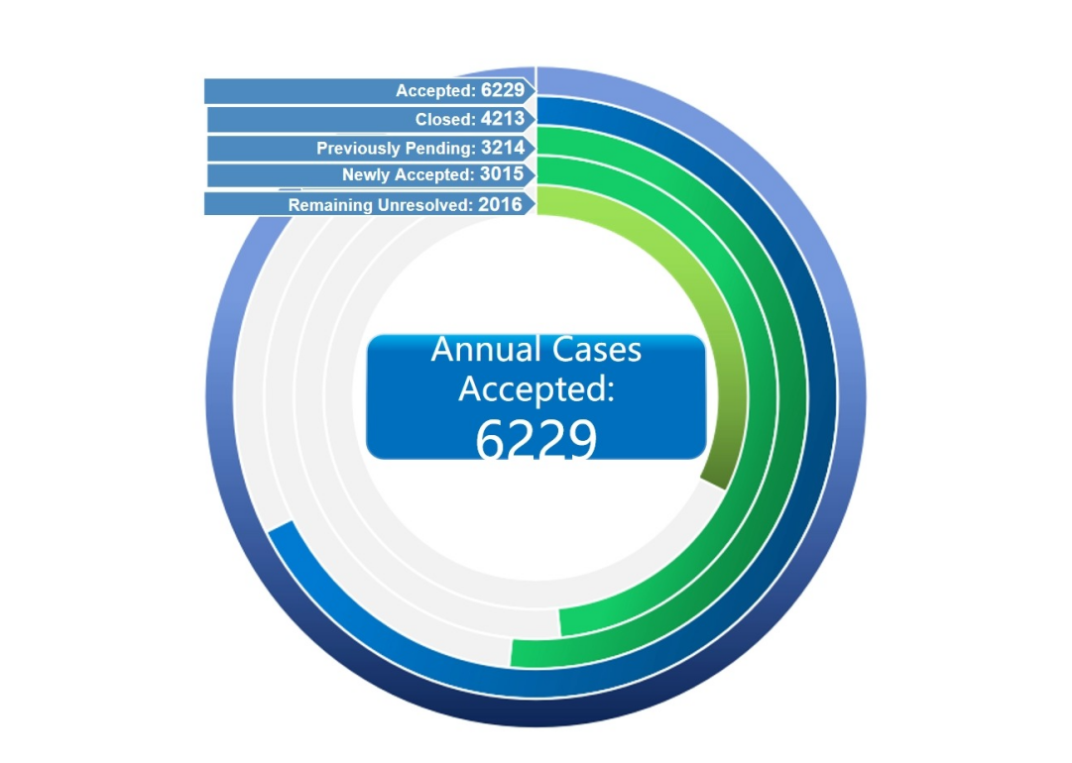In 2024, a total of 6,229 technology-related intellectual property and monopoly cases were accepted (including 3,015 newly accepted and 3,214 previously pending), with 4,213 cases closed and 2,016 pending cases remaining unresolved. Compared to 2023, the number of cases accepted decreased by 19.9% and the number of cases closed decreased by 7.7%.[47]

Figure 1 Overview of the Court’s Cases Heard in 2024

**II. Average case adjudication period**

In 2024, the average adjudication period for closed substantive cases was 253.9 calendar days, a decrease of 11.5 calendar days compared to the previous year. Among the cases, civil second-instance substantive cases averaged 254.1 calendar days, and administrative second-instance substantive cases averaged 253.3 calendar days.

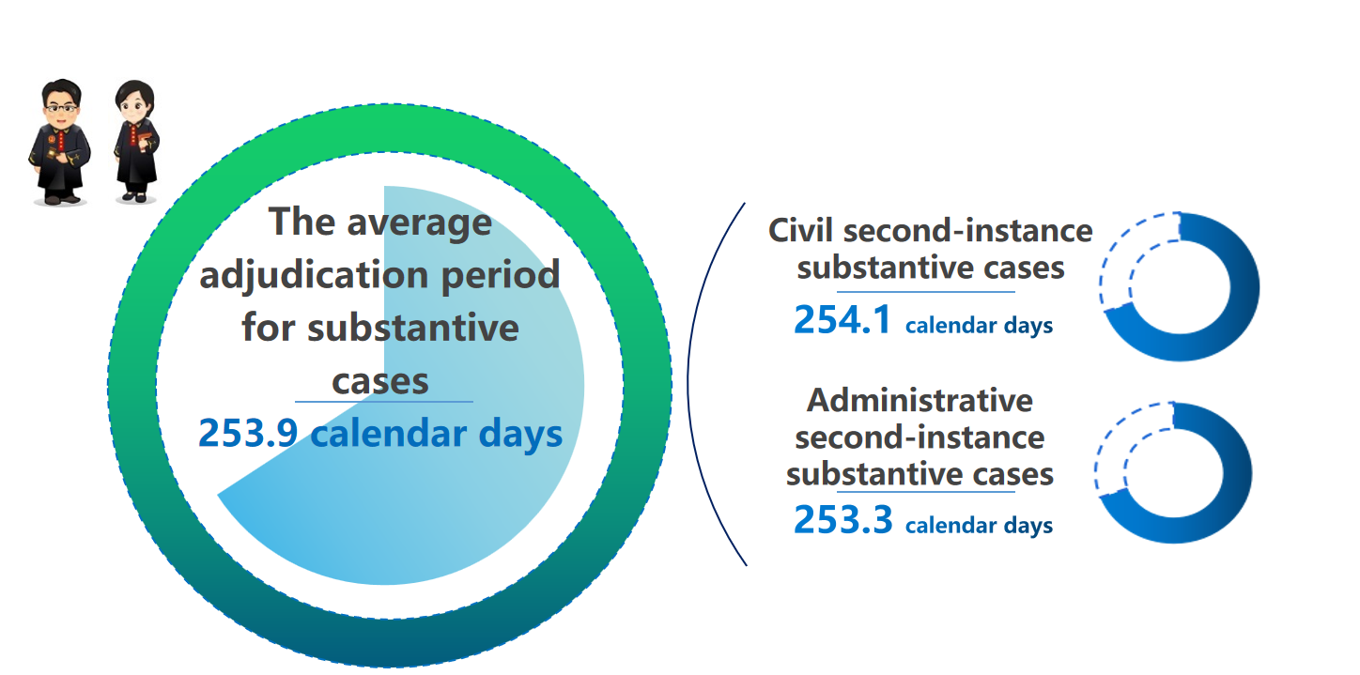

Figure 2: The Court’s Adjudication Period in 2024

**III. Classified data on civil cases**

The Court newly accepted 1,289 civil second-instance substantive cases in 2024. Among them, there were 753 disputes over the patents of inventions and the like, 264 computer software disputes, 164 new plant variety disputes, 42 monopoly disputes, 1 dispute over the layout design of integrated circuits, and 65 other disputes.

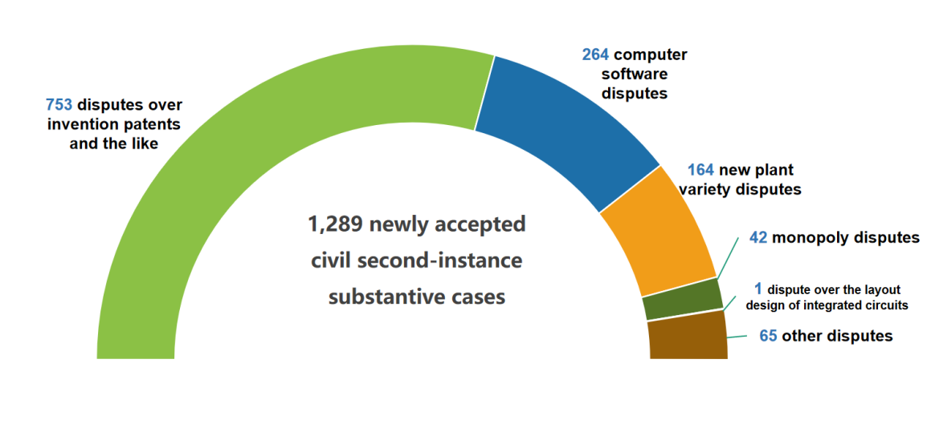

Figure 3 Classification of the Court’s Newly Accepted Civil Second-instance Substantive Cases in 2024

**IV. Classified data on administrative cases**

The Court newly accepted 1,366 administrative second-instance substantive cases in 2024. Among them, there were 253 disputes over the reexamination of rejected invention patent applications, 401 disputes over the invalidation of invention patents, 28 disputes over the reexamination of rejected utility model patent applications, 372 disputes over the invalidation of utility model patents, 2 disputes over the reexamination of rejected design patent applications, 240 disputes over the invalidation of design patents, 4 disputes over new plant varieties, 1 dispute over cacellation of the layout design of integrated circuits, 20 disputes over monopoly, and 45 disputes over administrative enforcement decisions and others.

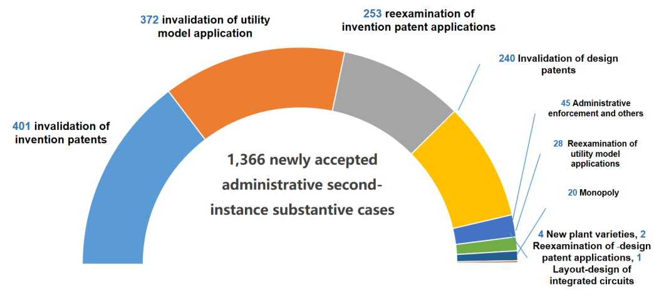

Figure 4 Classification of the Court’s Newly Accepted Administrative Second-instance Substantive Cases in 2024

**V. Case data based on the form of closure**

In 2024, a total of 4,213 cases were closed, with 2,294 cases closed by upholding the original judgment, accounting for 54.5%; 974 cases were closed by withdrawal (including withdrawal of appeal and withdrawal of lawsuit, the same below), accounting for 23.1%; 227 cases were resolved through mediation (issuing a civil mediation agreement, the same below), accounting for 5.4%; 2 cases were closed by remand for re-adjudication, accounting for 0.05%; 700 cases were closed by modification of the original judgment, accounting for 16.6%; 16 cases were closed in other forms, accounting for 0.4%.

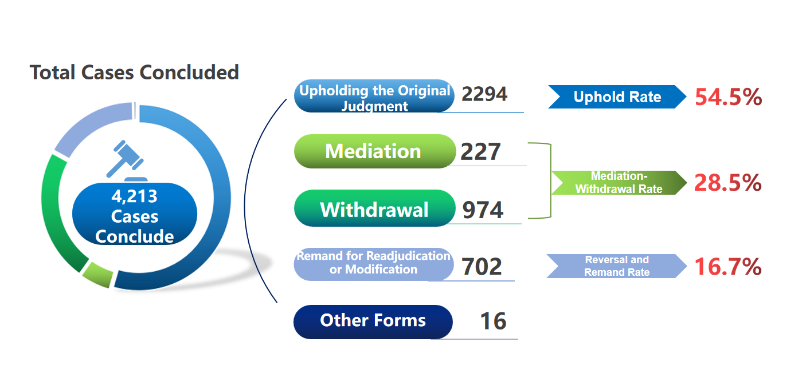

Figure 5: The Court’s Cases in 2024 Classified by the Form of Closure

Among the 2,476 civil second-instance substantive cases closed in 2024, 890 cases were closed by upholding the original judgment, accounting for 35.9%; 774 cases were closed by withdrawal, accounting for 31.3%; 227 cases were resolved through mediation, accounting for 9.2%; 2 cases were closed by remand for re-adjudication, accounting for 0.1%; 578 cases were closed by modification of the original judgment, accounting for 23.3% (after excluding the cases modified due to changes in the validity of rights, yielding an adjusted modification rate of 9.8%); 5 cases were closed in other forms, accounting for 0.2%.

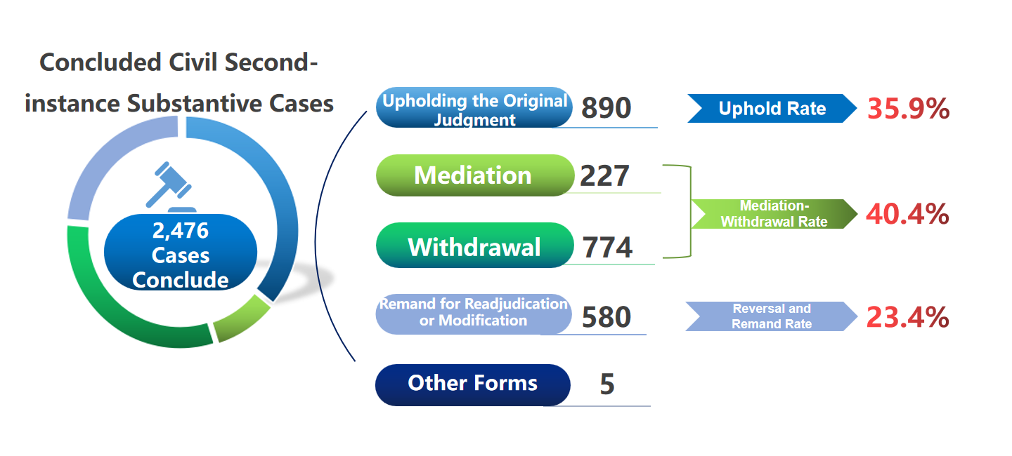

Figure 6: The Court’s Closed Civil Second-instance Substantive Cases in 2024 Classified by the Form of Closure

Of the 1,349 administrative second-instance substantive cases closed in 2024, 1,127 cases were closed by upholding the original judgment, accounting for 83.5%; 130 cases were closed by withdrawal, accounting for 9.6%; 92 cases were closed by modification of the original judgment, with a modification rate of 6.8%, and with no cases remanded for re-adjudication.

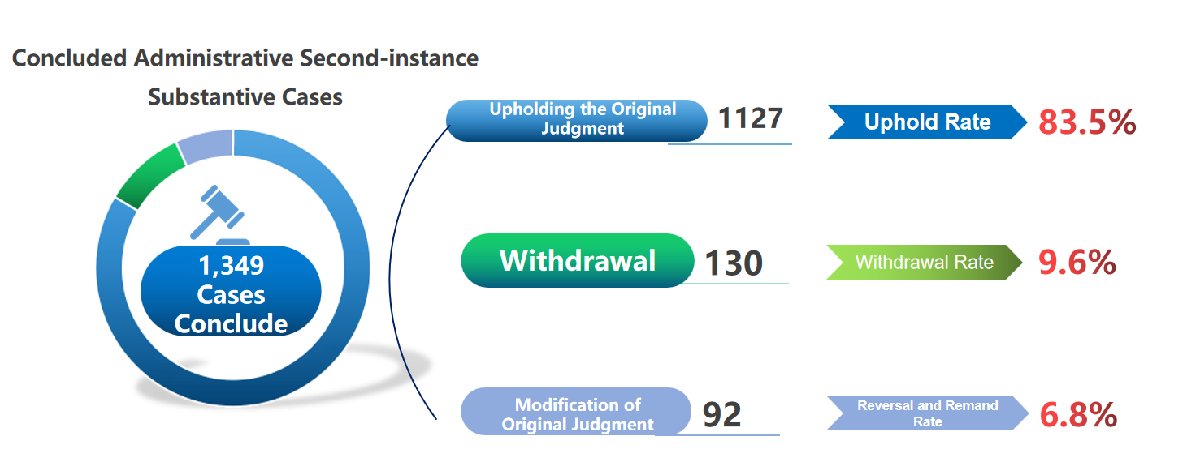

Figure 7 The Court’s Closed Administrative Second-instance Substantive Cases in 2024 Classified by the Form of Closure

**VI. Cases involving foreign parties or the parties from Hong Kong, Macao and Taiwan of China**

In 2024, 488 new cases involving foreign parties or parties from Hong Kong, Macao and Taiwan of China were accepted, a 0.41% year-on-year decrease, accounting for 16.2% of all new cases. Among them, 437 new cases involved foreign parties, accounting for 14.5% of all new cases; 51 new cases involved parties from Hong Kong, Macao and Taiwan of China, accounting for 1.7% of all new cases; 248 were civil cases and 240 were administrative cases. A total of 425 cases involving foreign parties or parties from Hong Kong, Macao and Taiwan of China were closed, reflecting an 8.7% year-on-year increase, accounting for 10.1% of the total cases closed.

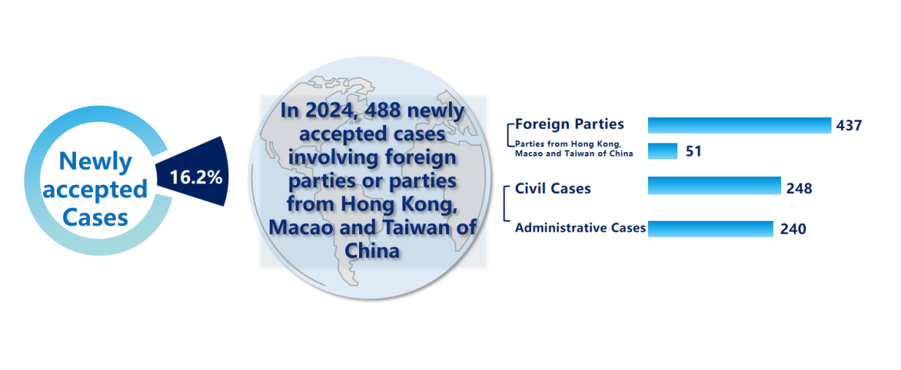

Figure 8: New Cases Involving Foreign Parties or Parties from Hong Kong, Macao and Taiwan of China Accepted in 2024

1. Civil Judgment of (2023) SPC IP Civil Final 1590.
2. The “Top Ten Cases Promoting the Rule of Law in the New Era” is an annual selection event jointly organized by The Supreme People’s Court and China Media Group (CMG).It aims to identify typical cases adjudicated by courts across the country and showcase the achievements of the rule of law in the new era.
3. Civil Judgment of (2022) SPC IP Civil Final 565.
4. Civil Judgment of (2022) SPC IP Civil Final 1362.
5. Civil Judgment of (2023) SPC IP Civil Final 1020.
6. Civil Judgment of (2022) SPC IP Civil Final 1742.
7. Civil Judgment of (2023) SPC IP Civil Final 141.
8. Civil Ruling of (2023) SPC IP Civil Jurisdiction Final 439.
9. Civil Rulings of (2023) SPC IP Civil Final 1593, 1594 and 1595.
10. Civil Judgments of (2022) SPC IP Civil Final 1062 and 1194.
11. Administrative Judgment of (2023) SPC IP Admin. Final 262.
12. Administrative Judgment of (2023) SPC IP Admin. Final 801.
13. Civil Judgment of (2023) SPC IP Civil Final 2618, Civil Judgment of (2024) SPC IP Civil Final 592.
14. Administrative Judgment of (2023) SPC IP Admin. Final 91.
15. Civil Ruling of (2023) SPC IP Civil Final 871.
16. Civil Judgments of (2023) SPC IP Civil Final 2911 and 2912.
17. Administrative Judgment of (2022) SPC IP Admin. Final 811.
18. Civil Judgment of (2022) SPC IP Civil Final 1843.
19. Civil Mediation Agreements of (2022) SPC IP Civil Final 2172 and 2242, (2023) SPC IP Civil Final 468, 470, and 1457.
20. Civil Rulings of (2023) SPC IP Civil Final 1113, 1114, 1115, 1116, 1117 and 1118.
21. Civil Judgment of (2023) SPC IP Civil Final 2044.
22. Administrative Judgment of (2023) SPC IP Admin. Final 2.
23. Administrative Judgment of (2021) SPC IP Admin. Final 847.
24. Civil Judgment of (2022) SPC IP Civil Final 1574.
25. Civil Ruling of (2024) SPC IP Civil Review 1.
26. Civil Meditation Agreement of (2023) SPC IP Civil Final 1000.
27. Civil Judgment of (2023) SPC IP Civil Final 1547.
28. Civil Judgment of (2023) SPC IP Civil Final 653.
29. Civil Rulings of (2023) SPC IP Civil Final 566, 567, 2860 and 2861, (2024) SPC IP Civil Final 458.
30. Civil Judgment of (2023) SPC IP Civil Final 539.
31. Civil Judgment of (2022) SPC IP Civil Final 1592.
32. Decision of (2024) SPC IP Judicial Punishment 1.
33. Administrative Judgment of (2022) SPC IP Admin. Final 472.
34. Civil Judgment of (2023) SPC IP Civil Final 1295.
35. Civil Judgment of (2022) SPC IP Civil Final 483.
36. Civil Judgments of (2022) SPC IP Civil Final 1631 and (2023) SPC IP Civil Final 1403.
37. Civil Judgment of (2023) SPC IP Civil Final 625.
38. Administrative Judgment of (2022) SPC IP Admin. Final 287.
39. Civil Ruling of (2023) SPC IP Civil Jurisdiction Final 328-2.
40. Civil Rulings of (2024) SPC IP Civil Final 914 and 915.
41. Fengqiao Experience is a grassroots governance model that emphasizes resolving disputes locally through community mediation and administrative coordination, thereby preventing escalation into fomal judicial or criminal proceedings.
42. Civil Meditation Agreement of (2023) SPC IP Civil Final 2041.
43. Civil Meditation Agreements of (2024) SPC IP Civil Final 866, 867, 868, 869, 870, 871, 872 and 873.
44. Civil Meditation Agreement of (2023) SPC IP Admin. Final 31.
45. In 2021, the "Jinjing 818" rice seed fake-license infringement case was selected; in 2022, the first drug patent linkage lawsuit in China was nominated; in 2023, the invention patent and technical secret case involving "Melamine" was selected; in 2024, the technical secret infringement case involving the "New energy vehicle chassis' was selected.
46. The Opinions were issued on December 31st, 2024.
47. Note: The main reason for the decrease in the number of cases accepted is that the Court adjusted its scope of case acceptance from November 2023, no longer newly accepting appeals on general civil infringement and administrative litigation of utility model patents, technical secrets and computer software.